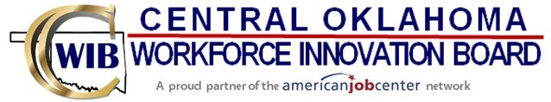

**United States Department of Labor**

**Board of Chief Elected Officials**

**Okfuskee County**

Jeff Morphis

**Logan County**

Mark Sharpton

**Lincoln County**

Lee Doolen

**Hughes County**

Dwight Barnett

**Canadian County**

Tracey Rider

**Cleveland County**

Rod Cleveland

**Chief BCEO**

**Pottawatomie County**

Melissa Dennis

**Grant Recipient**

Gov Kevin Stitt

**Seminole County**

Timothy Porter

**Oklahoma County**

Jessica Clayton for Brian Maughan

**State Workforce Board**

Oklahoma Office of Workforce Development

**Fiscal Agent**

**Central Oklahoma Workforce Innovation Board**

**Chair**

Richard Brown

**Vice Chair**

Darci Williams

**Executive Committee**

**Finance Committee**

